**Project Proposal**

**Fine Payment Management System for Police Department**

**Sri Lanka**

**INTE 21533-Information System Modelling**

**INTE 21543 Interactive Application Design & Development**

**Student Group: 09**

**Student No. Name**

Handapangoda L. E. IM/2018/028

Wimarsha D.G.H. IM/2018/096

Wijesinghe A.V.A.P. IM/2018/094

Perera T.P.S.S. IM/2018/061

Afshan M.A.N. IM/2018/005

Ranidu M. IM/2018/066

**Bachelor of Science Management & Information Technology**

**Department of Industrial Management**

**Faculty of Science**

**University of Kelaniya**

**21st June 2021**

**DECLARATION**

We here by certify that this project is our own work. It has not been submitted in respect of any other course module or taken from any other external sources.

**Student Group: 09**

**Student No. Name**

Handapangoda L. E. IM/2018/028

Wimarsha D.G.H. IM/2018/096

Wijesinghe A.V.A.P. IM/2018/094

Perera T.P.S.S. IM/2018/061

Afshan M.A.N. IM/2018/005

Ranidu M. IM/2018/066

Only for use by Lecturer/ Tutor

Assignment marks and Comments:

Total marks:

Weighting considered for the contribution:

Assessment Lecturer’s/Tutor’s initials:

ACKNOWLEDGEMENT

We would like to offer our gratitude to our lectures Dr. Shantha Jayalal and other staff members who provided the necessary guidance and strength towards completing this project.

Introduction

**Fine Imposing in Sri Lanka**

According to the information available on the Ministry of Transport, in Sri Lanka, there are over 700,000 driving licenses in 2019. According to the reports of the Sri Lanka police, numerous traffic violations are reported every day. In that case, actions will be taken to impose a fine on drivers for their offenses. Under the current system, drivers will be inconvenienced when paying fines, and the current process is wasting their time.

**Fine Imposing Process**

Currently, the Police department of Sri Lanka uses a completely manual system for the fine imposing and the fine payment process. The current process as follows.

The traffic police officers monitor vehicle driving and looking for drivers who violate the traffic rules. When the police officers notice a driver, who violated a traffic rule, they order the driver to stop the vehicle. Then the police officers take the drivers information like identity card and driving license information. After that, they issue a spot fine statement to the driver and confiscate the driver's license.

Then the driver needs to obtain a fine payment form from the traffic division of the police station. To obtain that form the driver should provide the spot fine permit to the police station. After obtaining the fine payment form, the driver visits the post office and settle the payment. Then he gets a paid receipt as the proof of the payment.

After making the payment the driver goes to the police station, shows receipt and police return driving license.

The driver can use the spot fine permit as a temporary license up to 14 days. If the driver could not make the payment within 14 days, he/she will be directed to the court.

**Problem Definition**

We have identified several problems in existing fine payment system because it is not an automation system and that creates many difficulties to the day-to-day activities of general public. According to the Sri Lanka’s law, when driver breaks a traffic rule while driving his/her vehicle, the police confiscate the drivers driving license and issue a spot fine statement. The problems we identified in the current system as follows,

* The driver has to visit the police station.
* The driver has to provide the spot fine permit.
* The driver has to visit post office and make the payment.
* The driver has only 14 days to complete the above task which takes a long time, otherwise, the driver will be directed to court.
* The diver must visit the respective police station that we have identified as a considerable time waste from the drivers’ side if he breaks the traffic rule far away from his residential area.

**Objectives of the Proposed System**

To maximize the efficiency of the existing manual traffic fine system, the suggested method proposes to implement a developed system using C#. In the existing system mainly, drivers face many difficulties. For instance, when a driver is caught for a traffic fine in an area far away from his residence, he has to come back to the police station which issued the spot fine statement to get his license. This is a main drawback in the prevailing traffic system.

As a solution for this, a system with unique functionalities is proposed to be developed. The system will be implemented to pay the fines online or sending the slip after bank deposits and verify the payment without visiting the police station.

The system provide facility to deliver the license back to the driver after the payment is done accordingly. Furthermore, the system is intended to have a user-friendly graphical user interface and the system will also provide statistical information when required.

**Scope of Project**

The project will cover the spot fine statement issuing and the fine payment process. It will computerize both activities currently done by the drivers and police officers manually. However, the system will not provide facilities to make fine payments at the police stations and it will not send any reminders to drivers about the deadline unless they visit the website and login using their license number.

**Feasibility Study**

**Financial Feasibility**

The Fine payment management system has a shared database that facilitates the accessibility to the necessary data through the internet. Therefore, to implement the system, there will be a cost in purchasing a shared database service.

Apart from that, the proposed system consists of a web application that provides the online payment facility by using the Payhere payment gateway service. For that, the system will have an associated hosting cost and Payhere account purchasing cost. Since the system will use small multimedia data transfer like payment slips, bandwidth requirement and server storage of the hosting plan is low. In purchasing the Payhere payment gateway, it is better to buy a Payhere premium plan to avoid the monthly payment limit.

The Associated Costs as follows (Estimated)

The budget for the proposed system is Rs:150,000/= (Assumed that the Police department has already agreed with that price)

Besides the above costs, there will be many benefits for both the police department and drivers in Sri Lanka. The police department will be able to keep all data collected from all police stations in one place and generate statistical reports when required. The drivers will be able to save a large amount of their time and a more convenient way to pay their fines. This project is financially feasible, because the estimated cost is lower than the budget.

**Technical Feasibility**

Fine Payment Management system is a computer-based application. Additionally, it has a mobile application and a web-based application as well. This project is associated with following main technologies and tools.

* Visual Studio
* Payhere Payment Gateway
* MySQL
* Xamarin Mobile app development
* HTML
* CSS
* JS
* PHP
* Diagram drawing and UI Designing tools
* Draw.io
* Figma

Each of the above technologies is freely available and required technical skills are manageable. For development and testing purposes the website will initially be published in a free web hosting space and a free MySQL service will be used. The payment gateway service provides a sandbox feature where we can make virtual payments for the testing purposes of the application. For later implementation, the system will be hosted in a paid web service and the system will use a database service and Payhere premium account.

From these, it is clear that the project is technically feasible.

**SYSTEM ANALYSIS**

**Using SSADM**

**2.1 BUSINESS ACTIVITY MODEL**

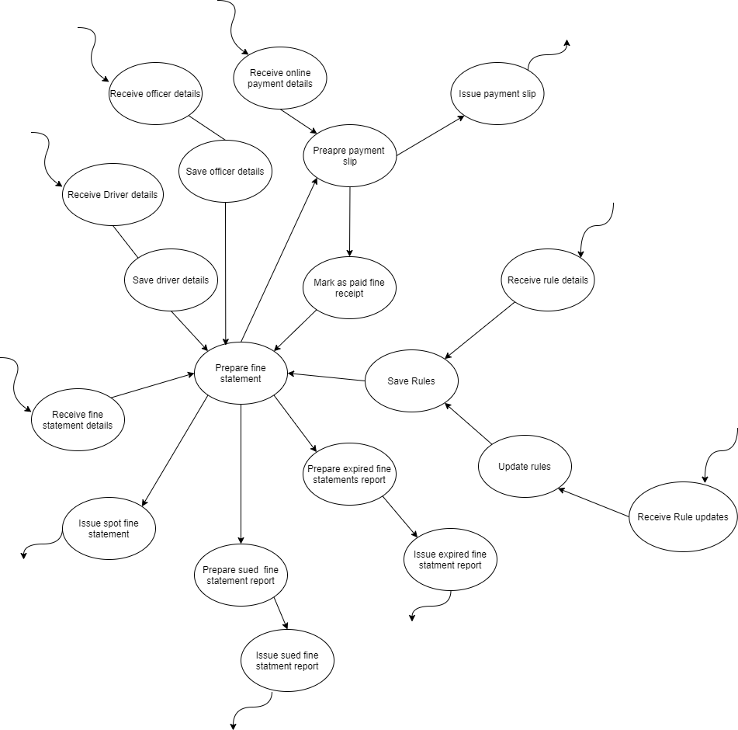

**2.2 CONTEXT DIAGRAM**

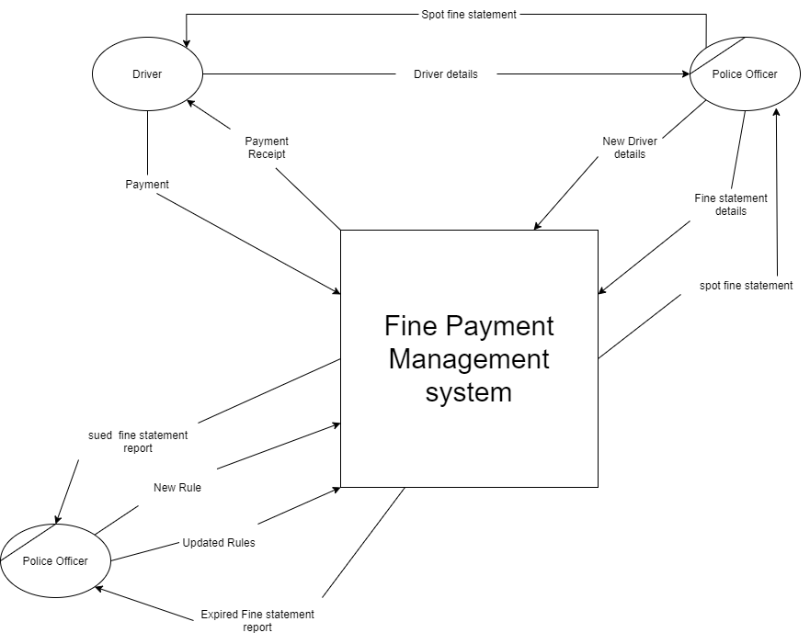

**2.3 DATA FLOW DIAGRAM**

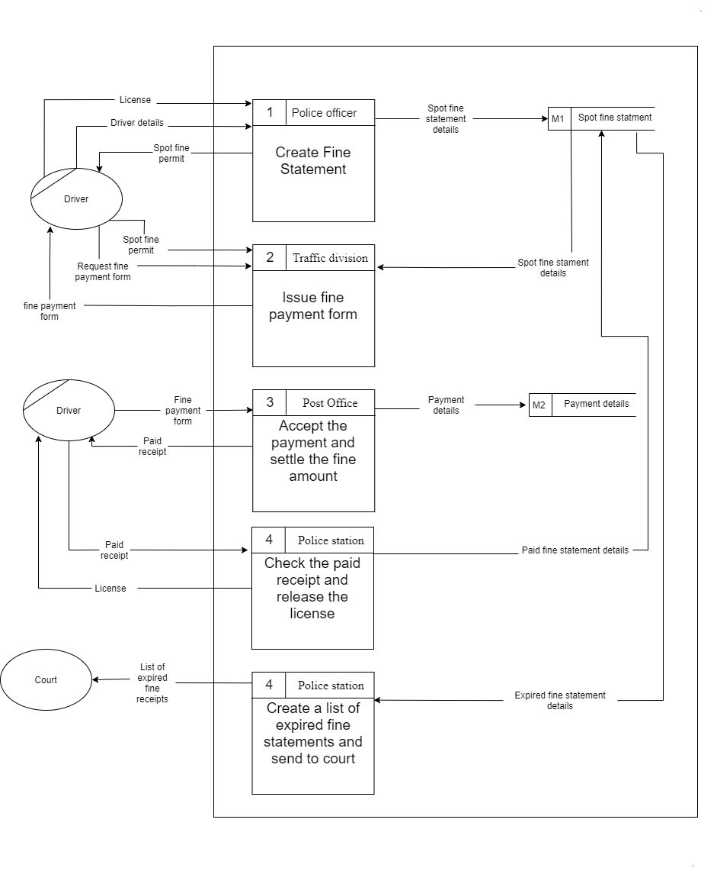

**2.4 LOGICAL DATA MODEL**

**2.5 REQUIREMENTS ANALYSIS**

|  |  |
| --- | --- |
| User ID | User Story |
| US-01 | As a driver when I violated a traffic rule and when the police checkpoint stopped me, I would give my information to the checkpoint. The information I would provide consists of my Driving license details, NIC details and additional information required by the police checkpoint. When the police officers issue the fine receipt after getting my details, I will have to leave my license with them and accept the spot fine statement as my temporary license until I make the fine payment. Later I will go to the police station and receives a fine payment form by providing the spot fine statement I received previously. After getting the fine payment form receipt I will go the post office and make the payment. After making the payment, I will go to the police station to take my license back by showing the paid receipt I received from the post office. |
| US-02 | I am a police officer. When driver violated traffic rules. I stopped the driver and request his or her details. At that moment I check license details, NIC details, and vehicle details. After getting details of the diver, I issued a fine receipt and kept his license. The spot fine permit issued, is considered as a temporary license until the driver pays the fine. After that, when a driver come to the police station and request a payment form by providing his/her spot fine permit, I will give a fine payment form to him/her. After that person returned with the paid receipt given by the post office, I verify the payment and release his/her license by returning their license. |

**Requirements Specification**

**Functional Requirements**

|  |  |  |
| --- | --- | --- |
| User ID | Requirement ID | Requirement |
| US-02 | FRQ-01 | Should be able to enter driver details and register him/her in the system. |
| US-02 | FRQ-02 | Should be able to select all rules violated by the driver. |
| US-02 | FRQ-03 | Should be able to issue a spot fine statement to a driver. |
| US-02 | FRQ-04 | Should be able to get a list of drivers who made the payment. |
| US-02 | FRQ-05 | Should be able to get a list of expired fine statement list. |
| US-01 | FRQ-06 | Should be able to get details of the spot fine information. |
| US-01 | FRQ-07 | Should be able to settle the fine payment through online payment. |
| US-01 | FRQ-08 | Should be able to get a payment receipt as a proof of the payment. |

**Non-Functional Requirements**

|  |  |  |
| --- | --- | --- |
| User ID | Requirement ID | Requirement |
| US-01 | NFRQ-01 | Shall be able to see the fine payment history |
| US-02 | NFRQ-02 | Shall be able to get statistical data |
| US-01 | NFRQ-03 | Shall be able to see the deadline of the payment |
| US-02 | NFRQ-04 | Shall be able to sort paid and unpaid fine list. |

Other than above non-functional requirements, the system has following non-functional requirements as well.

* The system should be simple and operatable for a user who as a general knowledge on operating computers and smartphones.
* It is good to have a simple and user-friendly interface for the application and the website.
* It is good to available system in all three languages Sinhala, Tamil and English which are commonly used in Sri Lanka.

**2.6 BSO’S**

BSO-01 – Mobile application, that would satisfy all the essential requirements of traffic police officers to easily add driver details and create fine statements.

BSO-02 – Multiuser web-based solution, that would satisfy all the essential requirements of both Police department and Driver’s

BSO-03 – Standalone application, that would satisfy all the essential requirements of the Police department

**SELECTED BSO**

**Functional Requirements**

|  |  |  |  |  |
| --- | --- | --- | --- | --- |
| Requirement ID | Requirement | BSO-01 | BSO-02 | BSO-03 |
| FRQ-01 | Should be able to enter driver details and register him/her in the system. | X | X |  |
| FRQ-02 | Should be able to select all rules violated by the driver. | X | X |  |
| FRQ-03 | Should be able to issue a spot fine statement to a driver. | X | X |  |
| FRQ-04 | Should be able to get a list of drivers who made the payment. |  | X | X |
| FRQ-05 | Should be able to get a list of expired fine statement list. |  | X | X |
| FRQ-06 | Should be able to get details of the spot fine information. | X | X | X |
| FRQ-07 | Should be able to settle the fine payment through online payment. |  | X |  |
| FRQ-08 | Should be able to get a payment receipt as a proof of the payment. |  | X |  |

**Non-Functional Requirements**

|  |  |  |  |  |
| --- | --- | --- | --- | --- |
| Requirement ID | Requirement | BSO-01 | BSO-02 | BSO-03 |
| NFRQ-01 | Shall be able to see the fine payment history |  | X  X | X  X |
| NFRQ-02 | Shall be able to get statistical data |  |  |  |
| NFRQ-03 | Shall be able to see the deadline of the payment |  | X |  |
| NFRQ-04 | Shall be able to sort paid and unpaid fine list. |  | X | X |

**3 SYSTEM DESIGN**

**3.1 USE-CASE DIAGRAM**

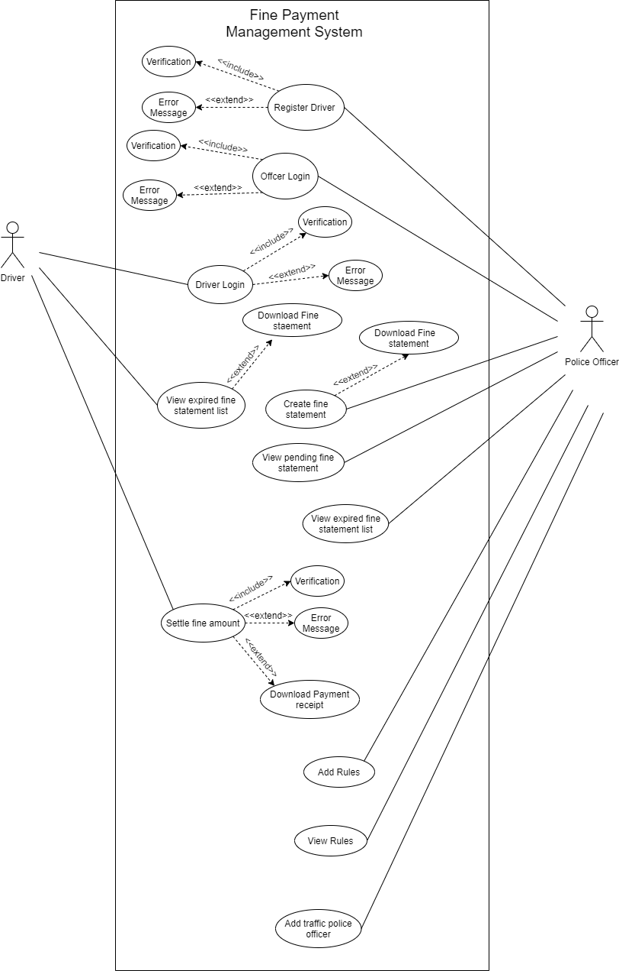

**3.1 USE-CASE DESCRIPTION**

|  |  |
| --- | --- |
| Name: | Login to the system – Police officer |
| Short description: | Police officer can login to the system by using their username and password |
| Precondition: | Police officer must authorize in the system |
| Postcondition: | Police officer logged in to the system |
| Error situation: | The username or password is invalid |
| System state in the event of an error: | An unauthorized access |
| Actors: | Police officer and database |
| Trigger: |  |
| Standard process: | Police officer logged in to the system |
| Alternative processes: | Re-enter the username and password |

|  |  |
| --- | --- |
| Name: | Register as police officer |
| Short description: | Enter username and verification code, then system will register as police officer |
| Precondition: | Enter personal details of police officer |
| Postcondition: | Registration is completed |
| Error situation: | Username or verification is invalid |
| System state in the event of an error: | Invalid information |
| Actors: | Police officer and database |
| Trigger: |  |
| Standard process: | 1. Police officer department ID 2. System will send verification code to police officer’s email 3. Police officer add that code in appropriate location of the app 4. Registration complete |
| Alternative processes: | 1. Re-enter Police officer details |

|  |  |
| --- | --- |
| Name: | Login to the system – Driver |
| Short description: | Driver can login to the system by using their username and password |
| Precondition: | Driver must authorize in the system |
| Postcondition: | Driver logged in to the system |
| Error situation: | The username or password is invalid |
| System state in the event of an error: | An unauthorized access |
| Actors: | Driver and database |
| Trigger: |  |
| Standard process: | Driver logged in to the system |
| Alternative processes: | Re-enter the username and password |

|  |  |
| --- | --- |
| Name: | Register as Driver |
| Short description: | Enter driver details then system will register as driver |
| Precondition: | Police officer must enter driver’s details to the system |
| Postcondition: | Registration is completed |
| Error situation: | Invalid NIC or License number |
| System state in the event of an error: | Invalid information |
| Actors: | Police officer and database |
| Trigger: |  |
| Standard process: | 1. Insert Driver details 2. Validate driver details 3. Registration complete |
| Alternative processes: | 1. Re-enter Driver details |

|  |  |
| --- | --- |
| Name: | Create fine receipt |
| Short description: | Enter driver detail and rules which driver has broken |
| Precondition: | The driver must be a registered driver in the system |
| Postcondition | Successfully created the fine receipt |
| Error situation: | NIC number is not available or invalid |
| System state in the event of an error: | Waiting for the user response |
| Actors: | Police officer and database |
| Trigger: |  |
| Standard process: | 1. Police officer enter the driver's NIC number to the system. 2. The NIC number is verified by the system 3. The violated rules are then entered 4. Successfully created the fine receipt |
| Alternative processes: | Redirect to the driver registration or re-enter the NIC number |

|  |  |
| --- | --- |
| Name: | Add Rules |
| Short description: | Enter government rules and regulations details to the system |
| Precondition: | The admin must logged in to the system |
| Postcondition | Successfully added new rule |
| Error situation: | One or more of these; description about rule, penalty amount or tag is not entered |
| System state in the event of an error: | Empty fields |
| Actors: | Admin and database |
| Trigger: |  |
| Standard process: | 1. Admin enter the description about rule, penalty amount and tag to the system. 2. Rule details save to the database 3. Successfully added new rule |
| Alternative processes: | Fill empty fields |

|  |  |
| --- | --- |
| Name: | View rules |
| Short description: | The admin can view government rules and regulations details |
| Precondition: | The admin must logged in to the system |
| Postcondition | The admin look on and update with the existing rules |
| Error situation: | Rule details not showing |
| System state in the event of an error: | Database connection failed or rules were not entered to the system |
| Actors: | Admin and database |
| Trigger: |  |
| Standard process: | Admin view all rules or can search and view a particular rule |
| Alternative processes: | Redirect to the add rule or refresh the page |

|  |  |
| --- | --- |
| Name: | View expired fine receipt list |
| Short description: | Police officer can view expired fine receipt |
| Precondition: | Driver has not pay fine receipts |
| Postcondition: | Police officer view expired fine receipt |
| Error situation: |  |
| System state in the event of an error: |  |
| Actors: | Police officer & database |
| Trigger: |  |
| Standard process: | Police officer view expired fine receipts |
| Alternative process: |  |

|  |  |
| --- | --- |
| Name: | View Pending fine statements |
| Short description: | Police officer can view pending fine receipt |
| Precondition: | Driver has pending fine receipt |
| Postcondition: | Police officer view pending fine receipts |
| Error situation: |  |
| System state in the event of an error: |  |
| Actors: | Police officer & database |
| Trigger: |  |
| Standard process: | Police officer view pending fine receipts |
| Alternative process: |  |

|  |  |
| --- | --- |
| Name: | Settle fine amount |
| Short description: | The driver visits the website and make the due payments using online payment portal. |
| Precondition: | The driver must have registered by a police officer and logged on to the system. |
| Postcondition | The driver makes a successful payment. |
| Error situation: | Payment fails. |
| System state in the event of an error: | Invalid card details or payment method doesn’t support online payments. |
| Actors: | Driver, Payhere payment gateway and database |
| Trigger: |  |
| Standard process: | 1. Driver proceed to payment. 2. Driver select a payment method and insert card details. 3. Driver make the payment 4. Payment successful. |
| Alternative processes: | Allow driver to use different payment method or redirect to main page. |

**3.2 ACTIVITY DIAGRAM**

**3.3 CLASS DIAGRAM**

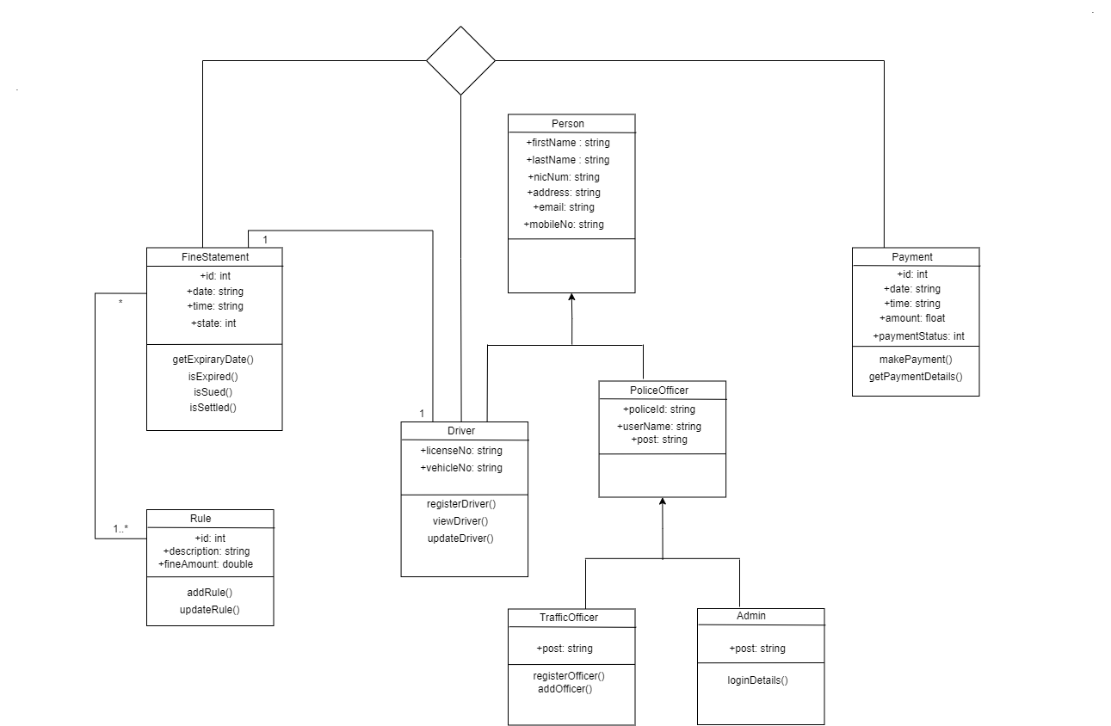

**3.4 GRAPHICAL USER INTERFACES**

**3.5 SEQUENCE DIAGRAM**

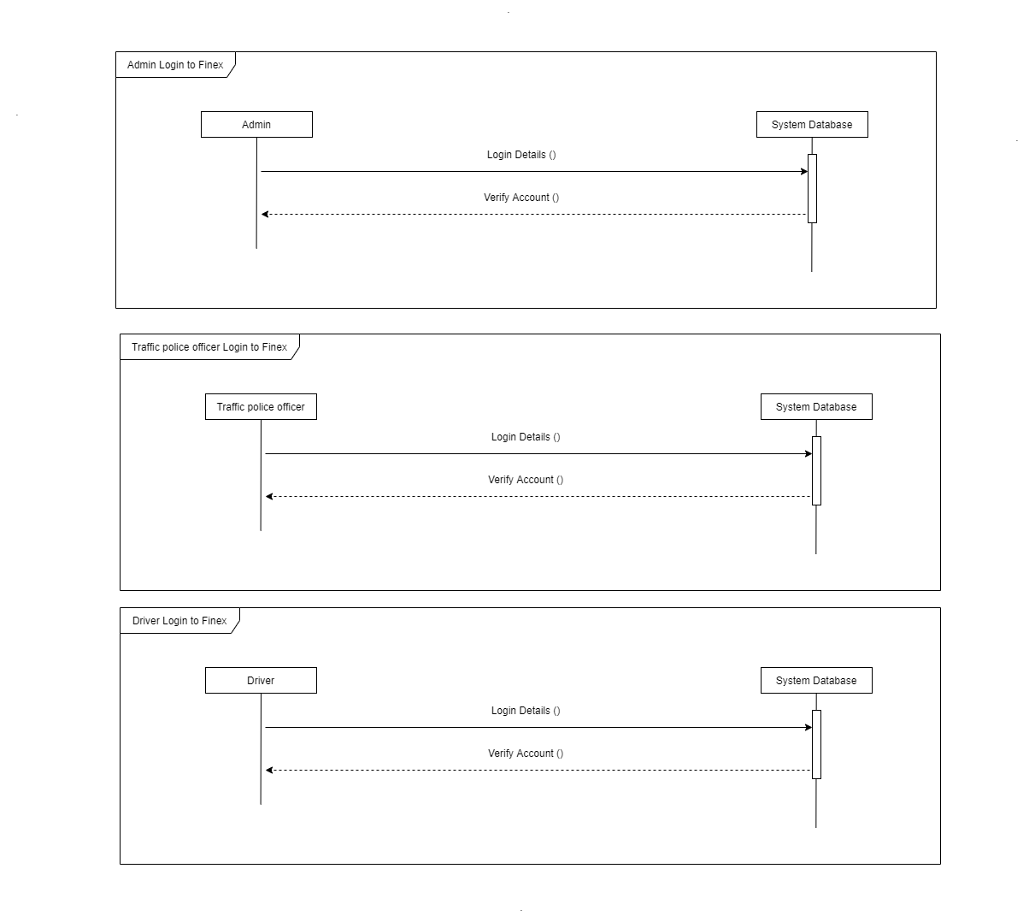

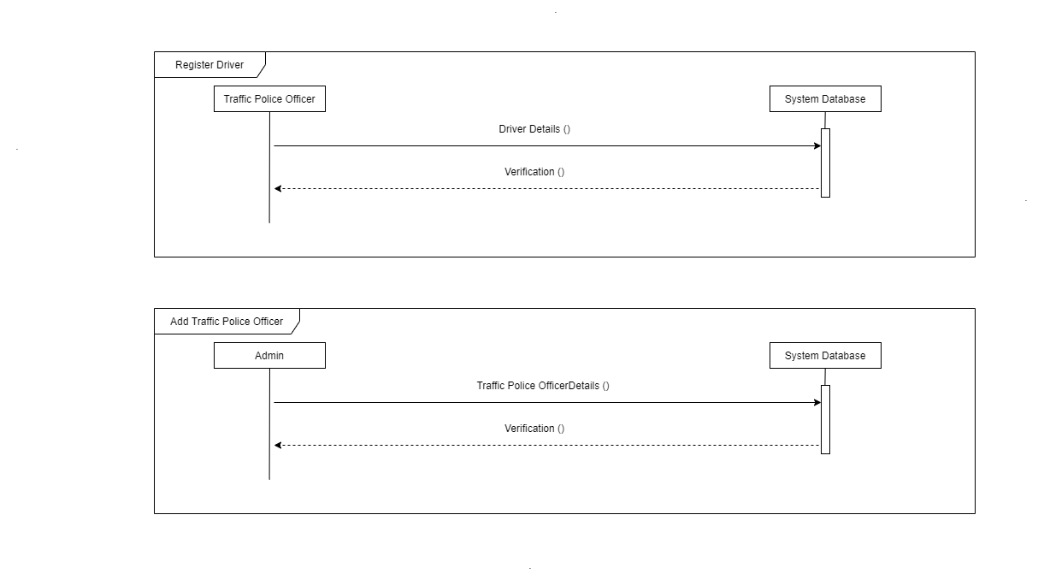

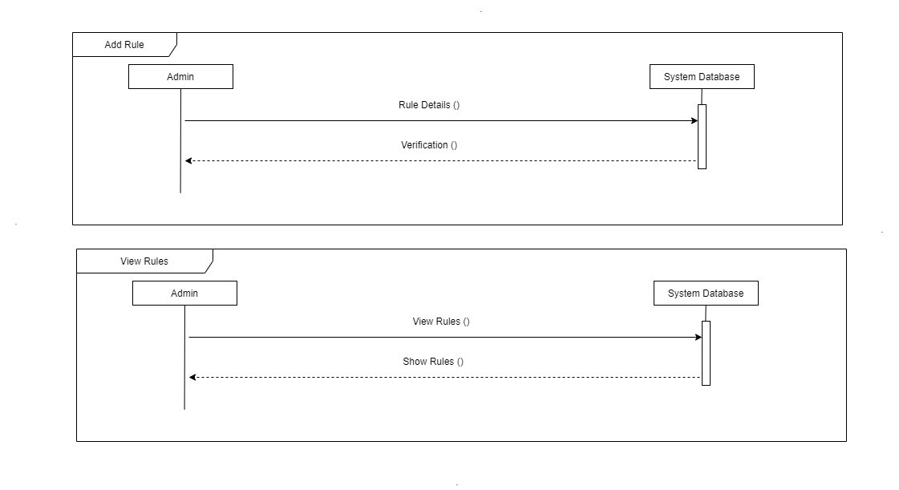

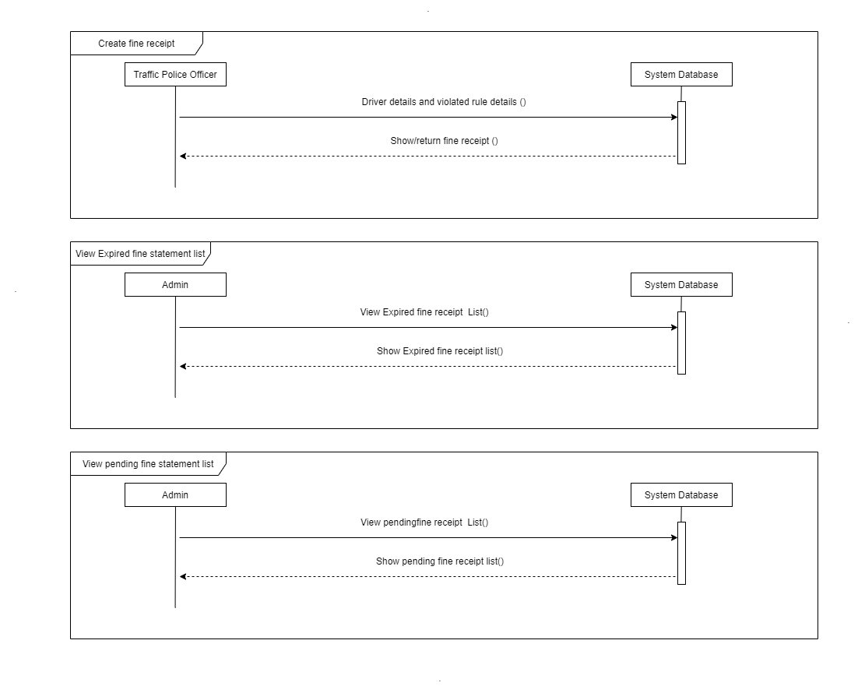

**4 EVALUATION AND CONCLUSION**

* 1. **DEGREE OF OBJECTIVE MET**

1. Mobile application will be provided to on duty police officers, and it can easily enter driver’s details
2. With mobile application, the officers can create the fine statement easily.
3. Through the website and desktop application police department can easily track and view recent details of rules violation and fine statements.
4. The standalone application allows to register new officers, edit both driver and officer details and add or edit rules as well.
5. Through our web application the driver can pay fined amount via online using their bank cards.
6. Both web and standalone applications allows police department to create various reports and see statistical data about the fine imposing process.
7. The desktop application automatically shows the expired license list, so that the police can create and send report to the court easily.

**4.2 USABILITY, ACCESSIBILITY, RELIABILITY AND FRIEDLINESS**

All the user interfaces are designed such a way that every user can use the application easily. We used dark colours for main content, and we highlighted special thing in light colours. We have used validation for all inputs to improve reliability of entire system. All the police officers with a valid username and a password can access the application. Registered drivers can login to the web application using their NIC number in order to settle the fine payments.

**4.3 LIMITATIONS AND DRAWBACKS**

1. System always needs to connect to internet, there are some low bandwidth areas in country, which can cause to limit our system.
2. For now, our mobile application is designed for android devices only.

**4.4 FUTURE MODIFICATIONS, IMPROVEMENTS AND EXTENSIONS POSSIBLE**

1. More user-friendly interfaces
2. IOS compatible mobile application
3. Collect data for future prevention (Identify High risk areas )
4. Implement AI technology to automatically detect rule violations and create fine statement for those drivers.

**CONCLUSION**

**ABSTRACT**